Aim:

To determine the volume magnetic susceptibility of Manganese sulphate solution at different concentrations.

Theory:

In electromagnetism, the magnetic susceptibility χ_{m} is a proportionality constant which is dimensionless and indicates the degree of magnetization of a material in response to an applied magnetic field. Mathematically, we express it as

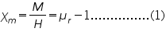
Where is the magnetization, H is the applied field andis the relative permeability of the material.

The Quincke's method is used for the determination of magnetic susceptibilities of many liquids, aqueous solutions and liquefied gases. Here we are determining the susceptibility of MnSO₄ solution (which is paramagnetic) at different concentrations. The experimental set-up used for Quincke's method is shown below,
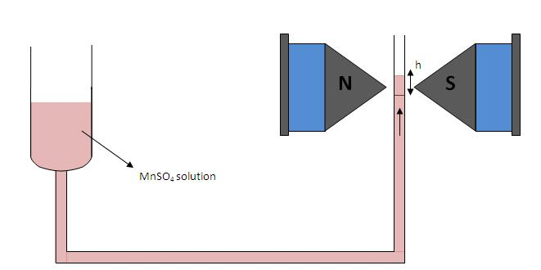
Arrangement for Quincke's method

Here Manganese sulphate solution under investigation is placed in a vertical U-tube with one limb of wide bore and the other with narrow bore. The narrow limb is placed in between the pole pieces of the electromagnet. It should be noted that the surface of the liquid in the narrow limb must lie at the line of centres of the pole pieces when the field is off.

When the current is switched on a strong field is appeared at upper surface of the narrow column while the lower portion will be in a state of comparatively weak field. Hence a force will act upon the column and if the liquid is paramagnetic it will rise.

We can derive an expression for the susceptibility of the liquid as given below,

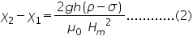

where χ₂, χ₁ are the susceptibilities of the solution and air; ρ, σ are the densities of liquid and air ; 'g' the acceleration due to gravity; 'h' the rise in the surface of the liquid; and H_{m} is the final field applied.

Taking the susceptibility of air approximately equal to zero, (2) becomes,

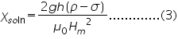

Controls

Combo box

Select procedure: This is used to select the part of the experiment to perform.

1) Magnetic field Vs Current
2) Quinke’s Setup

Slider

Current : Used to vary the current through the Solenoids.(From 0.5 A to 5 A).
Molarity: Used to change the Molarity of the liquid. (0.5 M to 1.5 M).

Button

Insert/ Remove Probe: This button used to insert/ Remove the probe to the magnetic field.
Show Voltage/ Current: This will activate only if Hall Effect setup selected. This button used for display the voltage/ current in the digital meter, which connected to Hall probe.
Reset: to reset the experimental setup.

Procedure for doing simulator

For measure the magnetic field generated in the solenoid
- Select the procedure combo-box Magnetic field Vs Current
- Click Insert probe button
- Then click on the wooden stand for place the probe on the middle of the solenoid.
- Using the Current slider, vary the current flowing through the solenoid and note down the Gauss meter reading. And fix the slider in any current. Once it is fixed, no need of changing this slider for completing the experiment.

Trial No: | Current flowing through solenoid | Magnetic field generated
1
2
3
4

Table 1

